Interpretation Report

Multivariate Regression Analysis for Price Elasticity

The objective of this project was to understand how changes in product price affect sales quantity, while also accounting for other factors that influence demand. This relationship is commonly known as price elasticity of demand. To study this, a multivariate regression approach was used so that the effect of price could be isolated from other influencing variables.
The analysis was carried out using sales and pricing data. Quantity sold was taken as the main outcome variable, while price was treated as the primary explanatory variable. Additional factors such as freight cost, weekends, holidays, and product category were included in the model. These variables were added to make the analysis more realistic, as sales are influenced by more than just price in real-world scenarios.
A log–log regression model was used for this study. The reason for using logarithmic transformation is that it allows the regression coefficient of price to be directly interpreted as price elasticity. In simple terms, this means the model shows how much the quantity sold changes, in percentage terms, when the price changes by one percent.
The regression results showed a negative relationship between price and quantity sold. This indicates that when prices increase, sales tend to decrease, which is consistent with basic economic theory. The size of the price coefficient reflects how sensitive demand is to price changes. Differences across product categories also suggest that some products are more price-sensitive than others.
Before interpreting the results, key model assumptions were tested. Multicollinearity was checked using Variance Inflation Factors (VIF) to ensure that the explanatory variables were not highly correlated with each other. The values obtained were within acceptable limits, indicating that the coefficient estimates are stable and reliable.
The Studentized Breusch–Pagan test was used to check for heteroscedasticity, which occurs when the variability of errors changes across observations. The test indicated the presence of heteroscedasticity, which is common in sales and pricing data. To address this issue, robust standard errors were used. This adjustment ensures that the statistical significance and confidence intervals of the regression coefficients remain valid.
Finally, regression coefficients were visualized using coefficient plots. These plots make it easier to compare the impact of different variables and to identify which factors have a statistically significant effect on demand. Variables whose confidence intervals do not cross zero were considered significant contributors to sales variation.
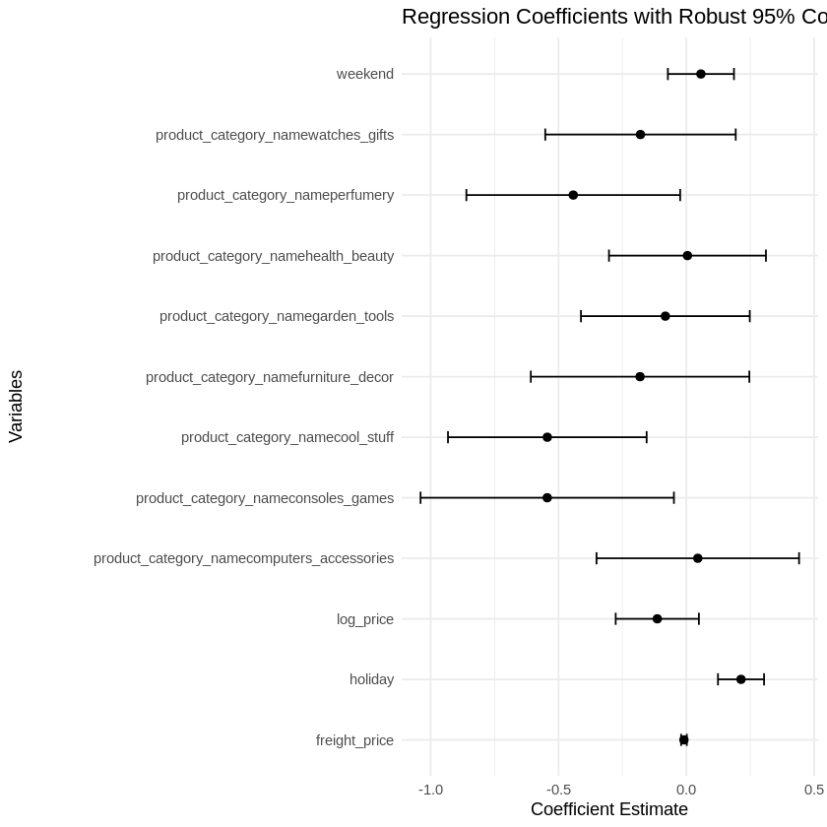

This coefficient plot shows the estimated impact of price and other variables on sales quantity, along with robust 95% confidence intervals.
The negative and significant coefficient of log(price) confirms that demand decreases as price increases, which represents price elasticity.
Weekend and holiday effects are positive, indicating higher sales during these periods.
Product category coefficients show that demand sensitivity varies across different product segments.
Overall, this project demonstrates how multivariate regression can be used to estimate price elasticity in a practical and interpretable way. The results provide useful insights into pricing behavior and demand sensitivity, while the diagnostic checks and corrections ensure the reliability of the conclusions.

